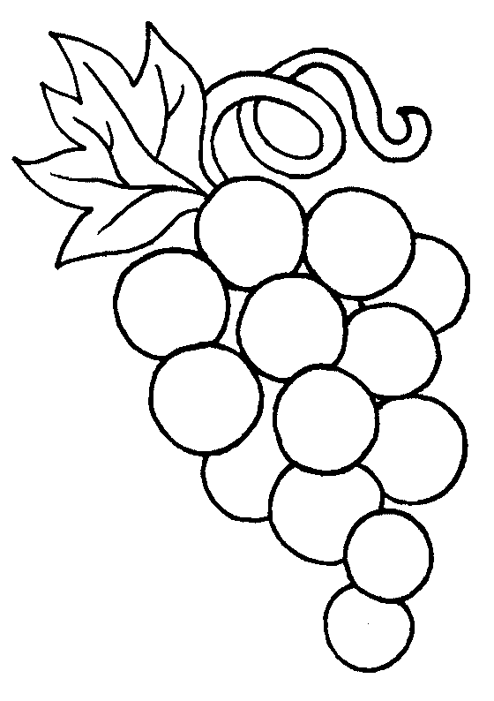
What is G-R-A-P-E-S?
Slide 1
- What is a ___________________________?
  - A ___________________________ is a society with cities, a central _____________________, workers who specialize in certain jobs leading to _____________ classes.
  - Must have a stable ___________ supply

- What does it mean to be ____________________?
  - When a society reaches an advanced stage of social _____________________ and ________________________.
    - Example: keeping ________________ records
Slide 2
- What is ___________________?
  - ___________________ is the beliefs, customs, arts, etc. of a certain society, group, place, or time
- List 3 types of culture in your life
  - 1. ____________________________
  - 2. ____________________________
  - 3. ____________________________

Slide 3
- ________________________- how climate and landscape affect the ______________
  - _______________ is the civilization located?
  - What natural _______________________ are available?
  - What were some of the key geographical features in the area?
  - How did the ____________________ of the civilization affect its development?
  - Example: civilizations often began along_____________ because of the water supply

Slide 4
- ____________________ – _________________ about superhuman controlling power, especially God or gods
  - What factors contributed to the development of this __________________ or belief system?
  - What did this religion believe in?
  - How did religion shape other aspects of this __________________?
  - Example: Ancient Greeks believed in _______________ ____________

Slide 5
- _________________________ – the ___________________ works of a society, often related to art and architecture
  - What achievements (science/math inventions, writing, art/music, etc.) did this civilization _____________________?
  - What was the _______________ of these?
  - How are these still used __________________?
  - Example: millions of people still visit the Pyramids in Egypt
Slide 6
- ____________________ – Who runs the society and how it’s done
  - Who has the ________________ and how is it organized? Did everyone have an _________________ opportunity?
  - What may have led to these ___________________ practices?
  - Were there ______________? Who created them?
  - How was it different from today?
  - Example: A limited form of ________________________ was practiced in Athens

Slide 7
- _______________________– how a society uses its ________________________
  - How did the society ________________________ their resources?
  - Did they _______________ or use __________________?
  - What did they sell or trade?
  - How did _________________________relate to __________________?
  - Example: Gold has been a valuable resource in many civilizations

Slide 8
- _____________ ____________________– the different levels or classes in society
  - What was the social class ___________________?
  - Who was the most _________________________in society?
  - Who ___________________________ from social classes? Who was harmed?
  - How did social structure relate to other aspects of this ____________________?
  - Example: Indian society was divided into a rigid caste system

