Name: _____________________________

Hour: ______________
Pharaoh Research Report

Directions: You are going to be completing a 2-part project with our conclusion of our study of ancient Egypt. Please follow the directions for each part as listed below. We will be doing some research in class while the sarcophagus and typing of the pharaoh report are to be completed outside of class. I will be available before and after school if students would like to work on their projects here.

***PROJECT DUE MONDAY, NOVEMBER 2nd.

Part 1- Sarcophagus
-You will need a shoebox (or box with a lid) to complete this portion of the project. You are making a sarcophagus, or tomb, for your Pharaoh you’ve chosen to research. Your sarcophagus must have the following components:
-Death mask on the lid
-Please do an internet search of different death masks to make yours as “unique” as possible while still resembling the Egyptian sarcophagus
-Hieroglyphics on the sides of the box
-At least TWO amulets within the sarcophagus that your mummy will be taking with it through the afterlife

Part 2- Pharaoh Report
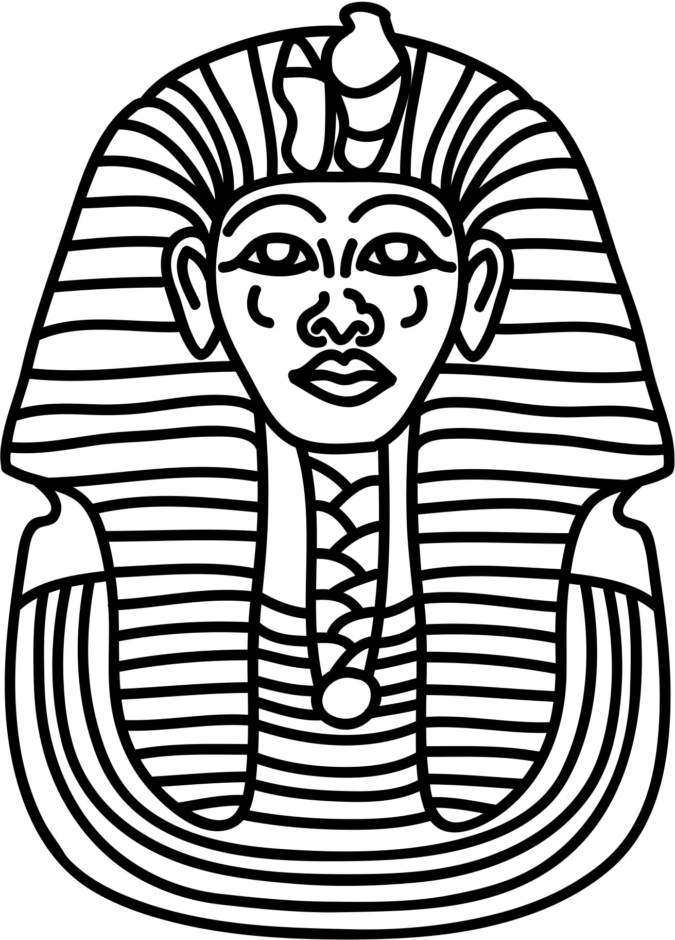
-You will be completing a report on your mummy which is going to represent a pharaoh of ancient Egypt. Please choose from the following list:
Ramses II
Hatshepsut
Thutmose III
Tutankhamun
Akhenaten
Khufu
-Your report will need to include the following components:
-Cover Page
-5 paragraph TYPED essay
-Picture Page
-Bibliography
- The report should include the information listed below:
- Describe events in the early life of the pharaoh and analyze their effect on the pharaoh.
- List the major accomplishments of the pharaoh and explain how this impacted the Egyptian civilization
- Tell at least three interesting facts about the pharaoh

Research Notes for Pharaoh Report on: _____________________________________

Use the chart below to record notes for your report. Each box should have at least 3 items as you will be writing a paragraph on each.

Describe events in the early life of the pharaoh and explain their effect on the pharaoh.
List the major accomplishments of the pharaoh and explain how this impacted the Ancient Egyptians.
Tell at least three interesting facts about the pharaoh you chose to research.

Bibliography

As researchers, we must always give credit to show where information was found so we do not plagiarize, or copy someone else’s work.

Use the chart below to list the websites or booked used for the report.

Website | Book Title & Author

