Mesopotamia Vocab Crossword
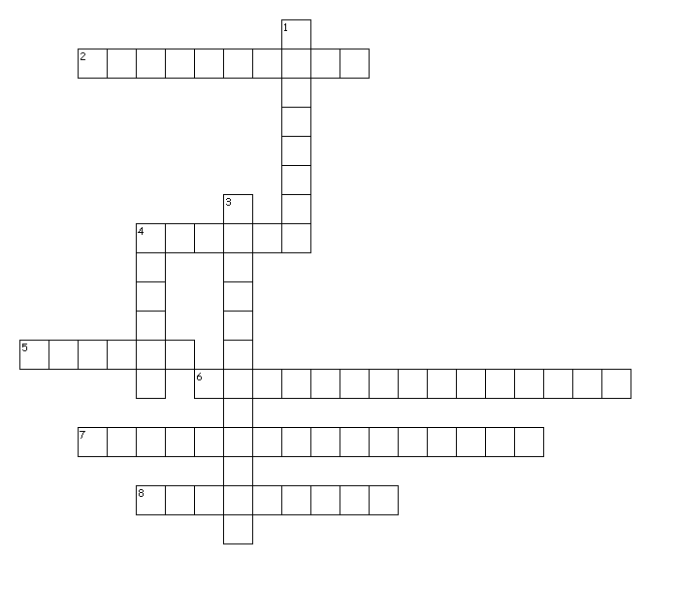
Across
2. belief in many gods
4. sending goods out to sell
5. Bringing in goods to sell
6. sharing of large jobs
7. moving water to dry areas
8. ancient writing that uses pictures to make words
Down
1. tall stepped tower used as a temple to a god
3. using wild plants and animals for work/farming
4. groups of people under control of a single government

